The


This month we are celebrating our children’s achievements!
We would love for you all to share some fabulous photographs of your child and their achievement/award for our celebration display at club via our email:
Willow@kidsclubgrouplimited.co.uk

This can be;
*Learning a new skill at home, like riding a bike, cooking etc.
*Achieveing the next level in swimming
*Tropy/medals for extra curricular or sports
*School award etc.

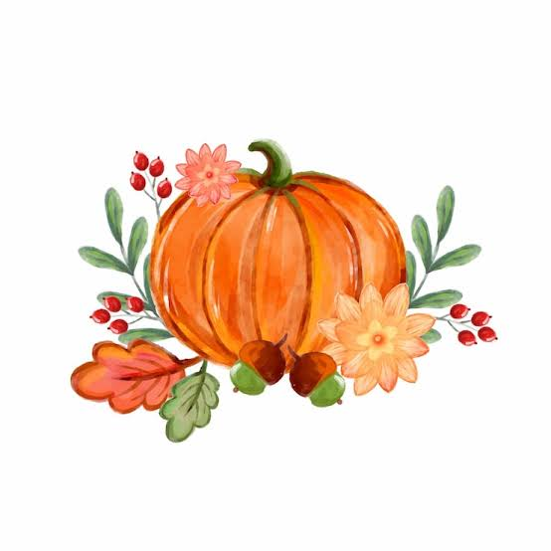

SPECIAL SHOUT-OUT!
 Michelle Bland

For all her amazing hard work and dedication in learning her new role at club and building amazing positive relationships with the children and team! xx

Absences from club:

TEXT or CALL us: 07821130662

Please make sure to continue to inform us every day if your child will be absent from club.
If they are attending extra-curricular activities, you need to be informing us of this as soon as possible.
This has become a very big issue for our drivers, as they have to comply with our collection policy and a strict time schedule to collect from other schools.

SPECIAL EVENTS THIS MONTH:

October - Arts & Crafts

5th -Finger painting
12th -Paddington tube character
19th -Pumpkin pie craft
26th – Please see our October Holiday Programme
❄️Our New Winter Menu is a Hit! ❄️

Our new winter menu has arrived, and it’s already proving to be a big hit!
The children have really enjoyed snack and exploring some of the new seasonal choices together. It’s been lovely to see so much enthusiasm around the table, and the amazing manners the children have shown towards the staff, thanking them for “a tasty snack,” and “I Love today’s snack!”

Keeping Everyone Safe 💚
Our new Allergy Awareness Display is now in place at the club! It’s another way we’re helping to keep allergy awareness at the forefront of everything we do. We’d really appreciate parents taking a moment to make sure we have the most up-to-date information about their child’s allergies and dietary requirements. If anything has changed, no matter how small, please let a member of the team know. xx

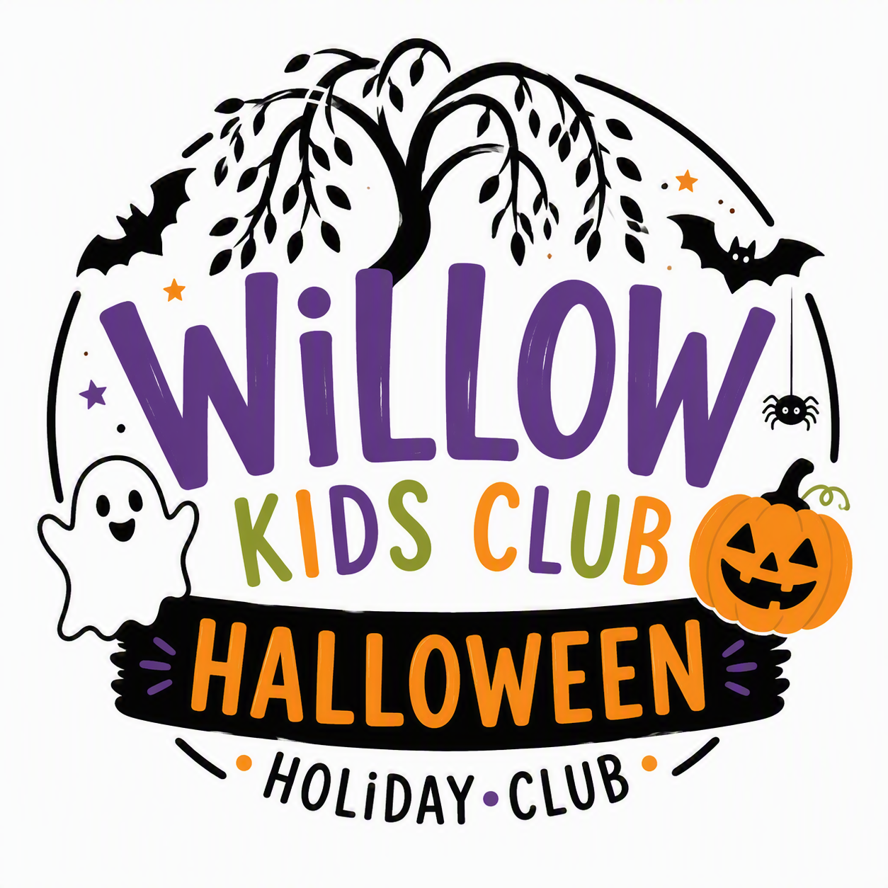


#

OCTOBER HOLIDAY CLUB!

Open From:
Friday 23rd October – Friday 30th October

Don’t forget to book your sessions to avoid disappointment

