The


The children had an amazing time for Spa Week for May holiday club! We loved reading all the lovely emails and seeing those cheeky smiles. 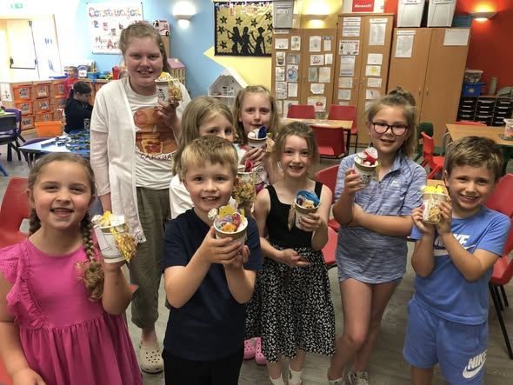

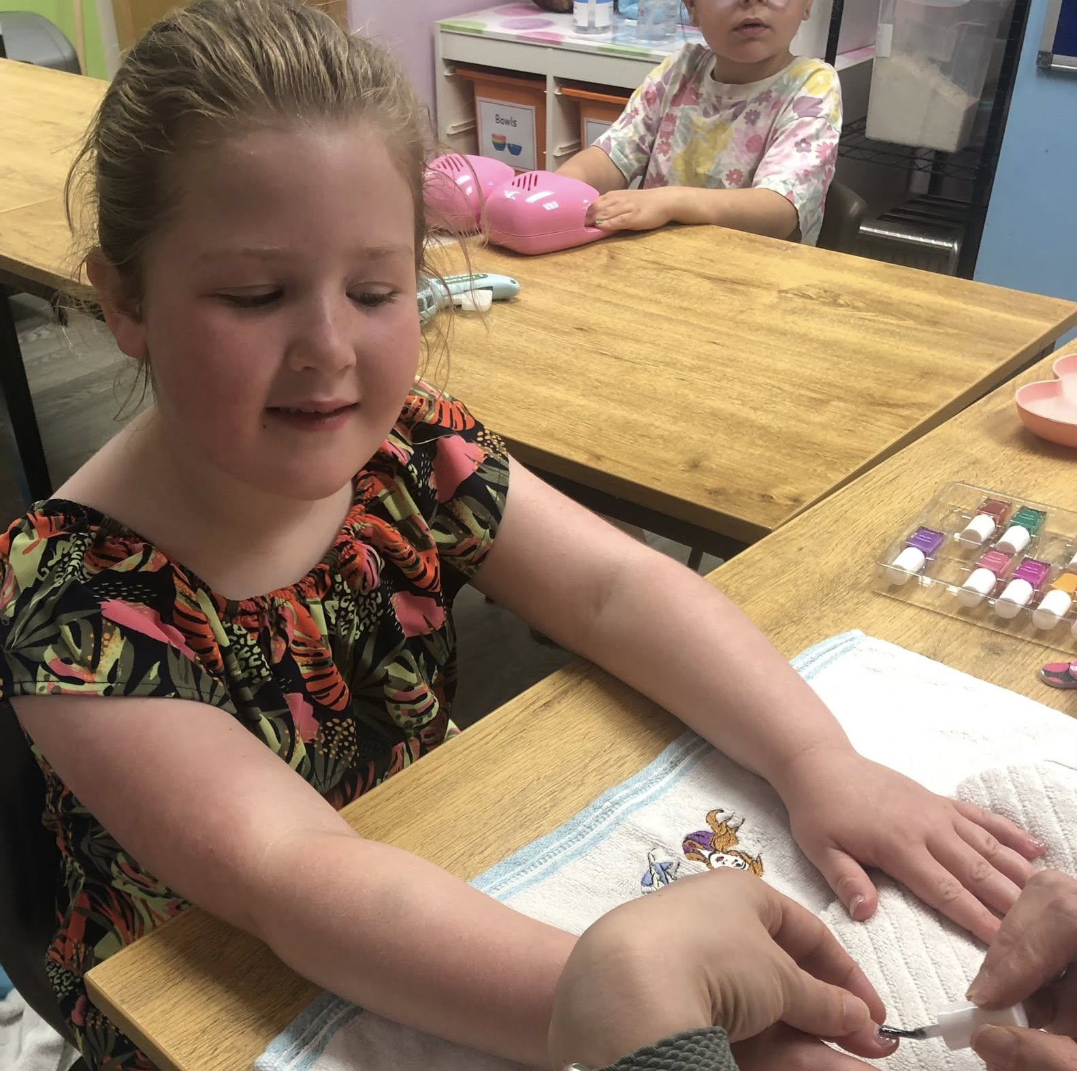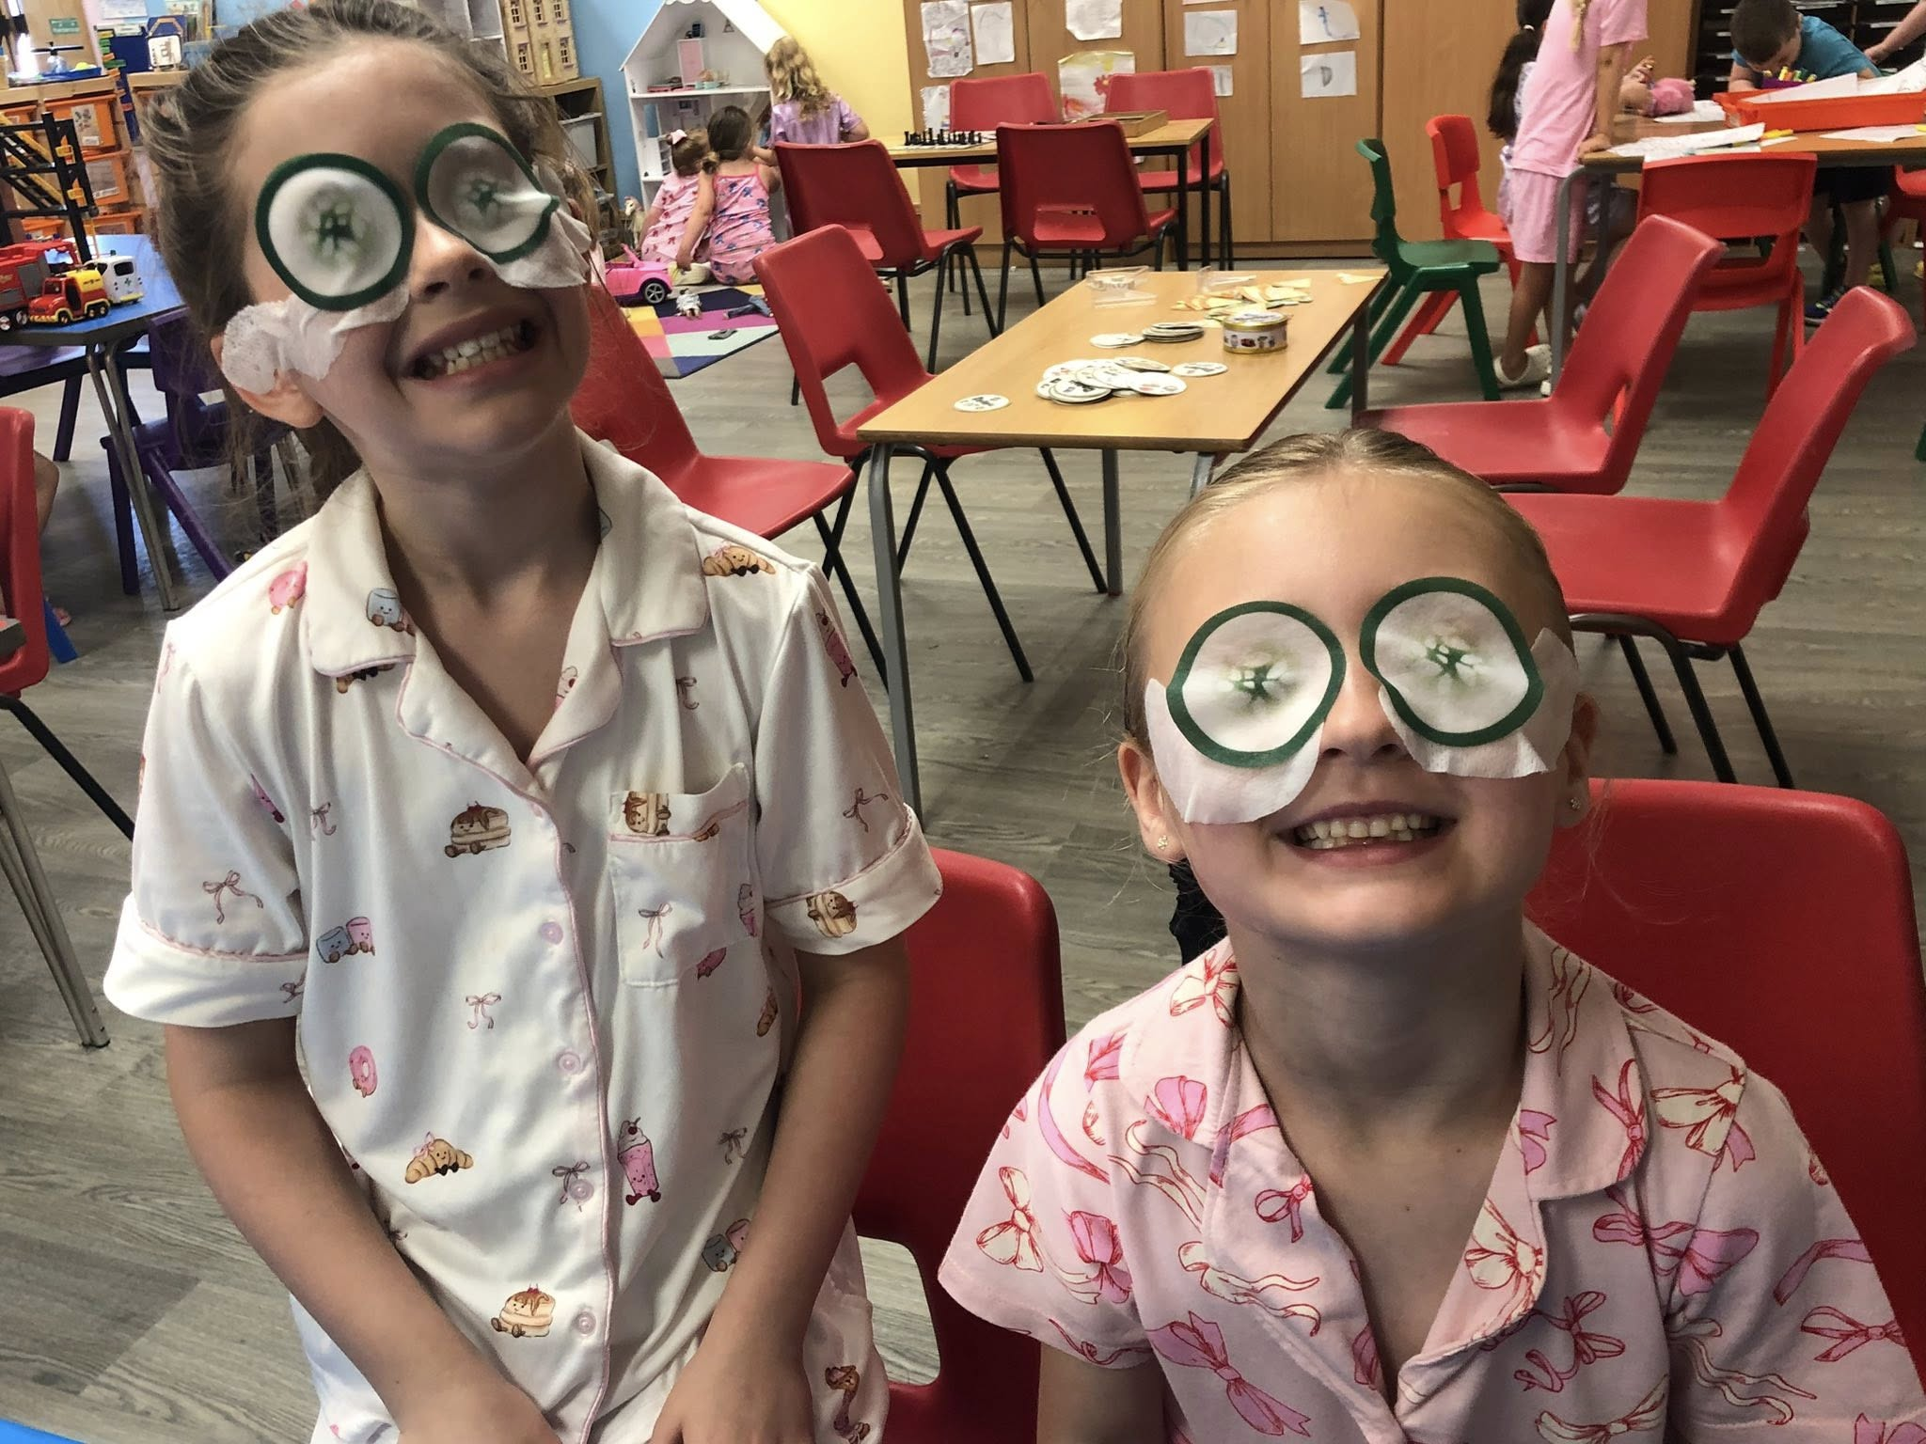

This June we are exploring different materials to make coral reef’s and sea creatures in recognisation of World Ocean and Sea turtle week, Celebrating Father’s Day & Club council and staff are working hard -
SUMMER PLANNING IN PROGRESS!

STAFF SHOUT-OUT!
Emma Mahon!
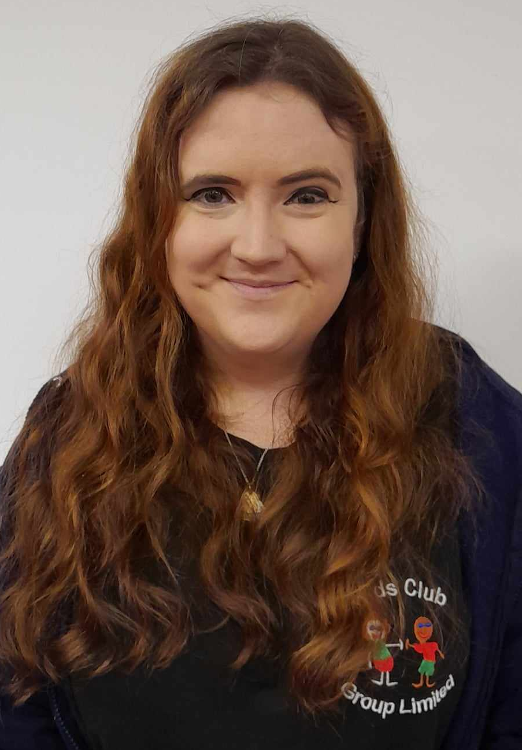
We would like to say a huge thank you to Emma for all her hard work and dedication in aiming for her finish date of her apprenticeship! NEARLY THERE! xx

Absences from club:

TEXT or CALL us: 07821130662

Please make sure to continue to inform us every day if your child will be absent from club.
If they are attending extra-curricular activities, you need to be informing us of this as soon as possible.
This has become a very big issue for our drivers, as they have to comply with our collection policy and a strict time schedule to collect from other schools.

SPECIAL EVENTS THIS MONTH:
Arts & Crafts
 1st June: World reef awareness day – junk modelling you own coral reef

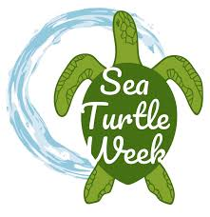8th June: Paper plate turtles – World Ocean Day
15th June: Create your own Lion


- 22nd June: Create your own musical instruments

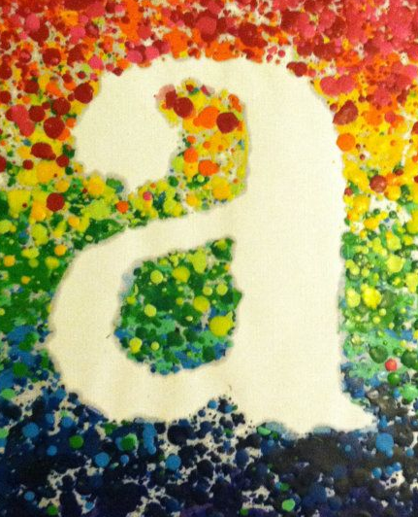29th June – Wax crayon Decorative Letter poster


WE ARE GATHERING IDEAS FOR EXPERIENCES & ACTIVITIES FOR THE SIX WEEKS SUMMER HOLS!!

We would appreciate any suggestions for summer trips that are local to us, that you think the children will enjoy!

✨CONFIRM YOUR PLACE FOR SEPTEMBER 2026!
 Breakfast Club • After-school club • Holiday Club

It is that time of year again when we ask for you to confirm your child's bookings for September 2026!
Children that will be starting school in September have now been allocated their school choices and we are being inundated with new requests.

We are asking for all our current families to confirm their PERMANENT sessions, giving you the opportunity to request additional sessions or request to drop any sessions by Friday 12th June to ensure that we can allocate and confirm places to our new starters for September 2026.

Please respond to the email as soon as possible: Willow@kidsclubgrouplimited.co.uk

I would like to take this opportunity to thank you all for your continued support. xx



#

We would like to say a MASSIVE well done to Dorothy, for being our amazing star of the month at Willow Kids Club.

She is always polite and always comes into club with the biggest smile on her face!

And one of the greatest dancers we have seen during our holiday club music sessions! xx

