


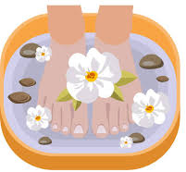

May Holiday Club Programme 2026 – SPA WEEK! 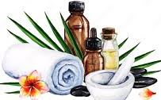
Monday 25th May | CLOSED - Due to Bank Holiday
Tuesday 26th May | Art & Craft: Design your own Sticker tote bag  Activities: Nail Salon and foot spa treatments
Wednesday 27th May  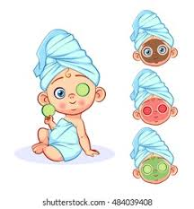 | PAJAMA PAMPER DAY – Come in your PJ’s!  Please don’t forget to bring in your £1.00 donation to help towards the cost of  treatments & Snack  Activities: Spa treatment; Facemask facials and head massage  Special snack: Afternoon tea; with triangle sandwiches, crisps, veggie sticks & dip, mini cakes & Orange/Apple juice.
Thursday 28th May | Arts & Craft: Handmade friendship bracelets  Activities: Hair salon – Styling gel and glitter &  Mindful Yoga class
Friday 29th May | Baking: Bubble bath duckling cupcakes  Activities: Movie afternoon - ‘Onward’ with popcorn

