
Can we please remind you how important it is to let us know at club of any absences or changes in school times for drop offs and pickups, as this has a major impact on the drivers’ strict time schedules.
Especially with the cold and snowy weather warnings this month.
The schools do not inform us of this information, so we would be very grateful if you can keep us as updated as much as possible.
The

We would like to wish all our amazing families and children a Happy New Year! We hope you all have had a lovely Christmas break.
We look forward to seeing you all back to term time Monday 5th January 2026.

This term’s Club council members have been working extra hard this week at club, coming up with some amazing activties and event ideas for February Holiday Club.
Keep a look out for our Holiday club Programme next week!

Please remember, February Holiday club starts from Monday 16th – Friday 20th February 2026.
7:30am – 6.00pm
Don’t forget to make your bookings to avoid disappointment.

Arts & Crafts:

5th January –
New Year Star wands
12th January –
Polar animal paper chains
19th January –
Paper plate Winnie the Pooh, in celebration of the author; AA.Milne
26th January -
Rosettes for Republic Day (Independence Day for India)

Absences/sickness: 
Please make sure to inform us of your child/ren’s Absence. This is becoming a really big issue, please let us know if your child/ren will not be attending club, as the schools don’t inform us of this.

This is very important as we have a strict time schedule to stick to, for our drivers to collect from other schools. If there is no answer, please leave a text or ring us on:
Mobile: 07821130662

Payments:
All invoices are sent out on 25th of each month and are due for payments within 7days, the payment date will be stated on the invoice email.
For any extra sessions booked, you will be invoiced on the following Monday, payment will be due within the 7days to -
Kids Club Group Limited
Sort code: 09-01-29
Account Number: 10234954
If you have any invoice queries or issues, please contact Lynne via email.
lynne@kidsclubgrouplimited.co.uk
or please call the ‘Accounts’ phoneline: 07754571303
Please try and contact us within the working hours; 7:30am-9:00am or 2:45pm-6:00pm.
Any messages received outside these times may not be dealt with until the following session.

#
LOST PROPERTY:
If you have any lost property, please make sure to check our lost property shelf at the front entrance.
There are still items from December holiday club that haven’t bee claimed. x

We would like to introduce you all to our newest staff members of the Willow Family. They have become such valued members of the team and built some fabulous relationships with the staff and children.
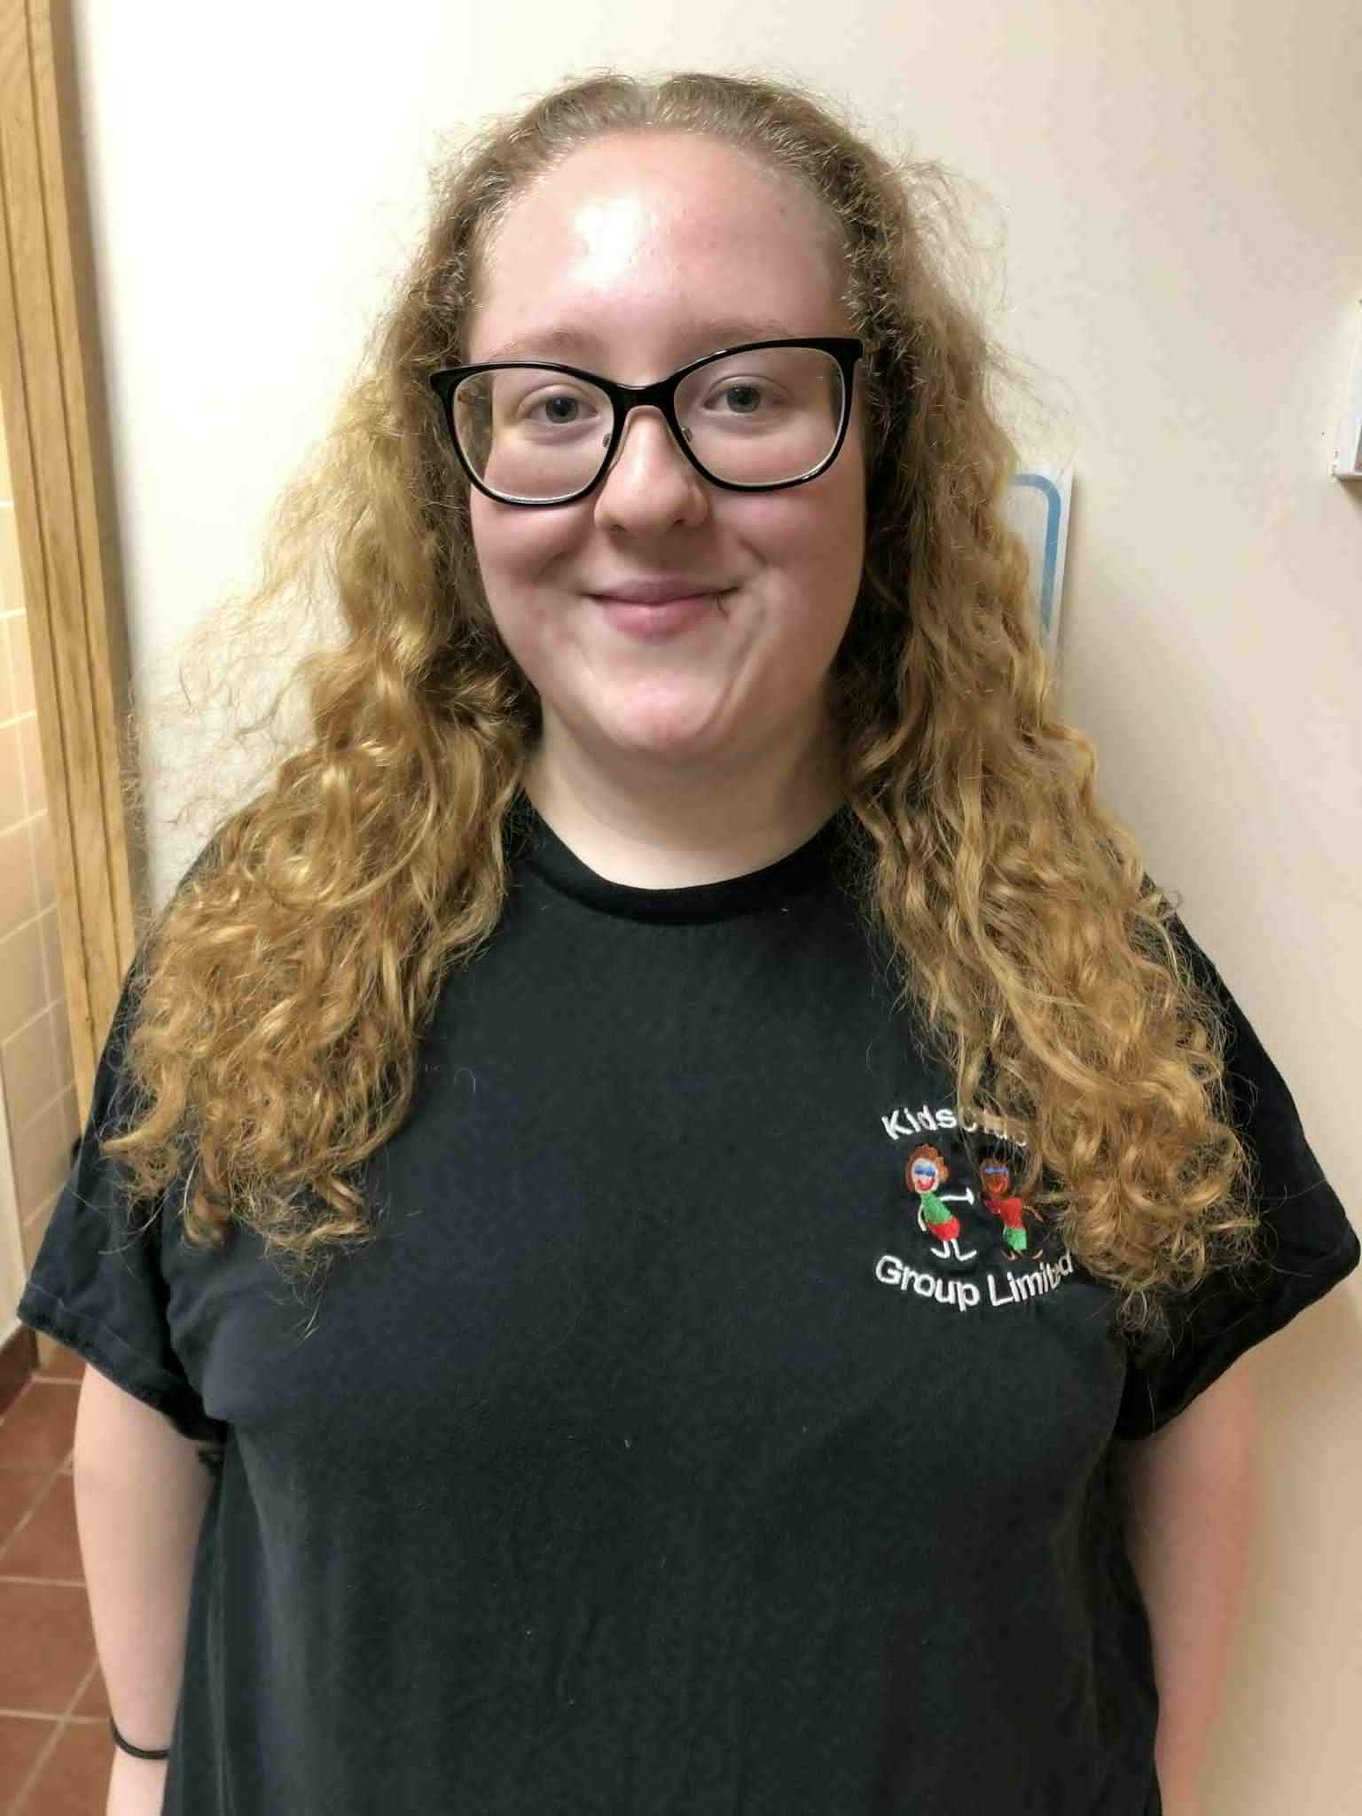

Alisha Mills – Hannah Pickering – Gracie Carr–
Apprentice Level 2 Level 3 Playworker Apprentice Level 2



