The

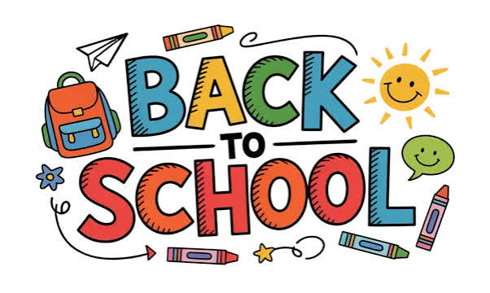

As summer comes to an end and we begin a new school year, we would like to take a moment to say a huge ‘Thank you’ to all of our amazing children for bringing your energy, smiles, laughter, creativity, and enthusiasm to our Summer Holiday Club and making so many happy memories together.
We hope you had a fantastic summer and wish you all the very best as you return to school. We cannot wait to hear all about your new classes and achievements next holiday club.
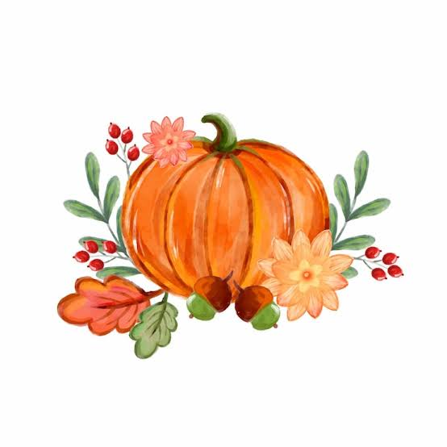
We would also like to extend our sincere thanks to all of our parents and carers for your continued support throughout the year.
Your trust in our team means so much to us, and it is a privilege to care for and support your children. Thank you for your patience, cooperation, and encouragement, which help us provide the best possible experience for every child attending the club.

The Willow Kids Club Team 💚xx

SPECIAL SHOUT-OUT!
Emma Mahon
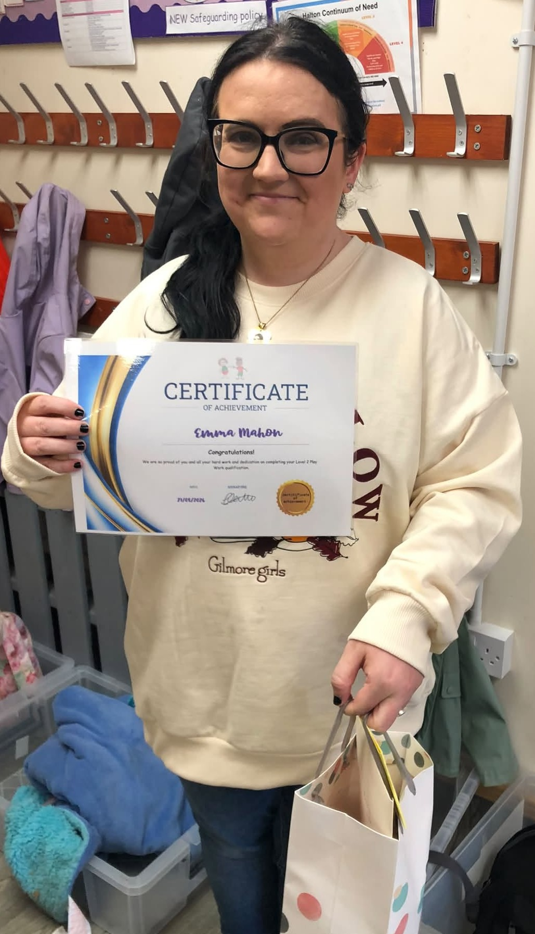
For all her amazing hard work and dedication in completing her Level 2 Apprenticeship in Play work! xx

Absences from club:

TEXT or CALL us: 07821130662

Please make sure to continue to inform us every day if your child will be absent from club.
If they are attending extra-curricular activities, you need to be informing us of this as soon as possible.
This has become a very big issue for our drivers, as they have to comply with our collection policy and a strict time schedule to collect from other schools.

SPECIAL EVENTS THIS MONTH:
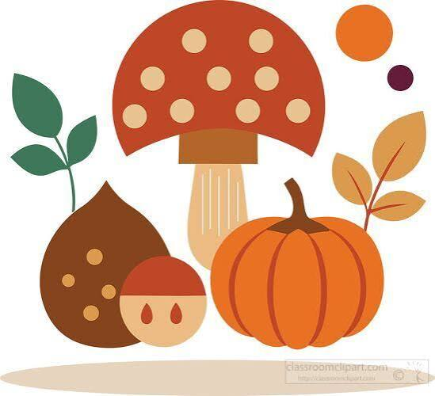
September - Arts & Crafts

7th Origami emoji bookmark
14th Sunflower paper loop art
21st Autumn silouette art
28th Look after your Heart Week

Please don’t forget to book your Adhoc sessions for breakfast and afterschool club before every Friday, as this affects staffing, food orders and pickups and collections.
Thank You to Our AMAZING Team! 🌟

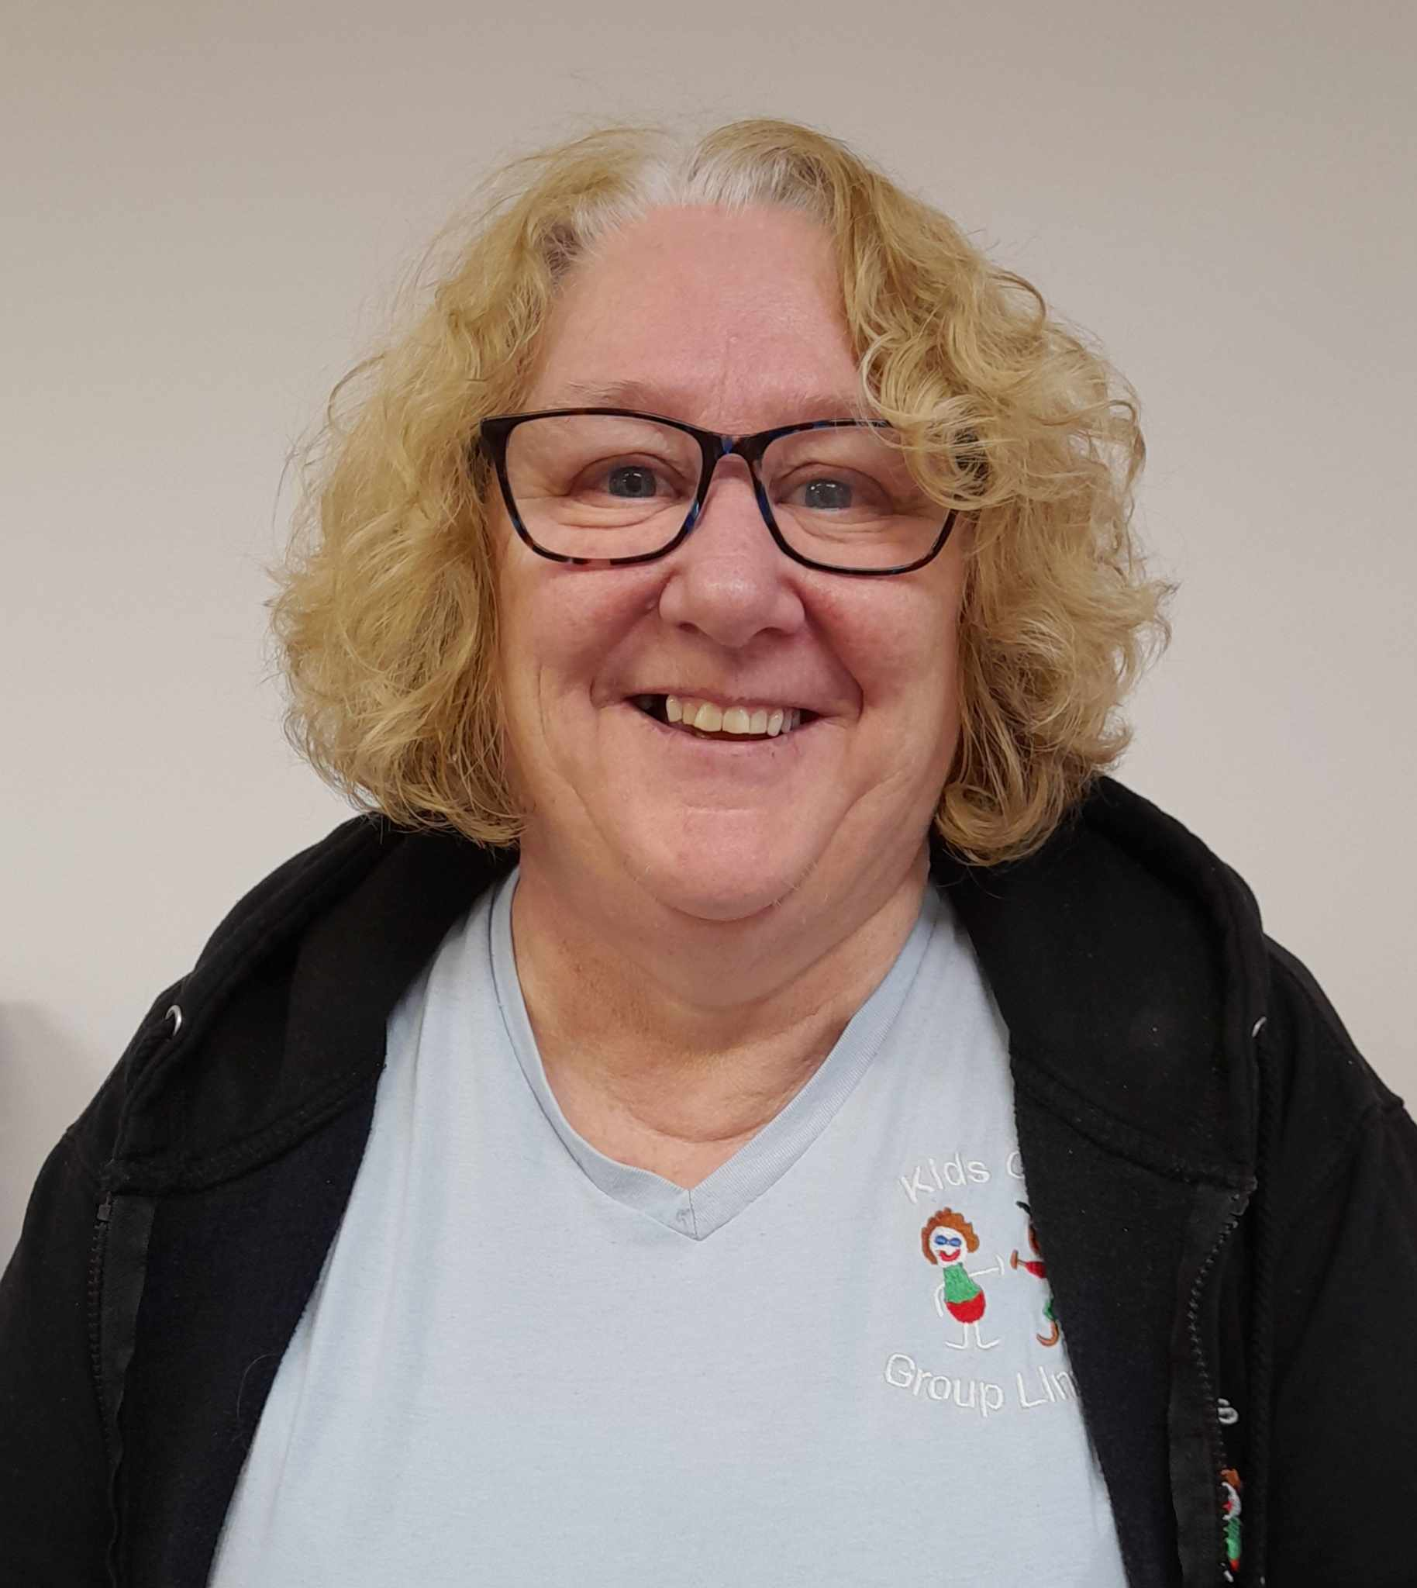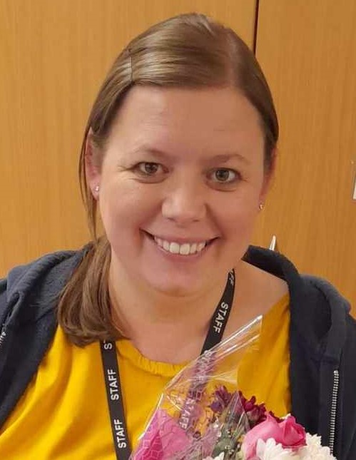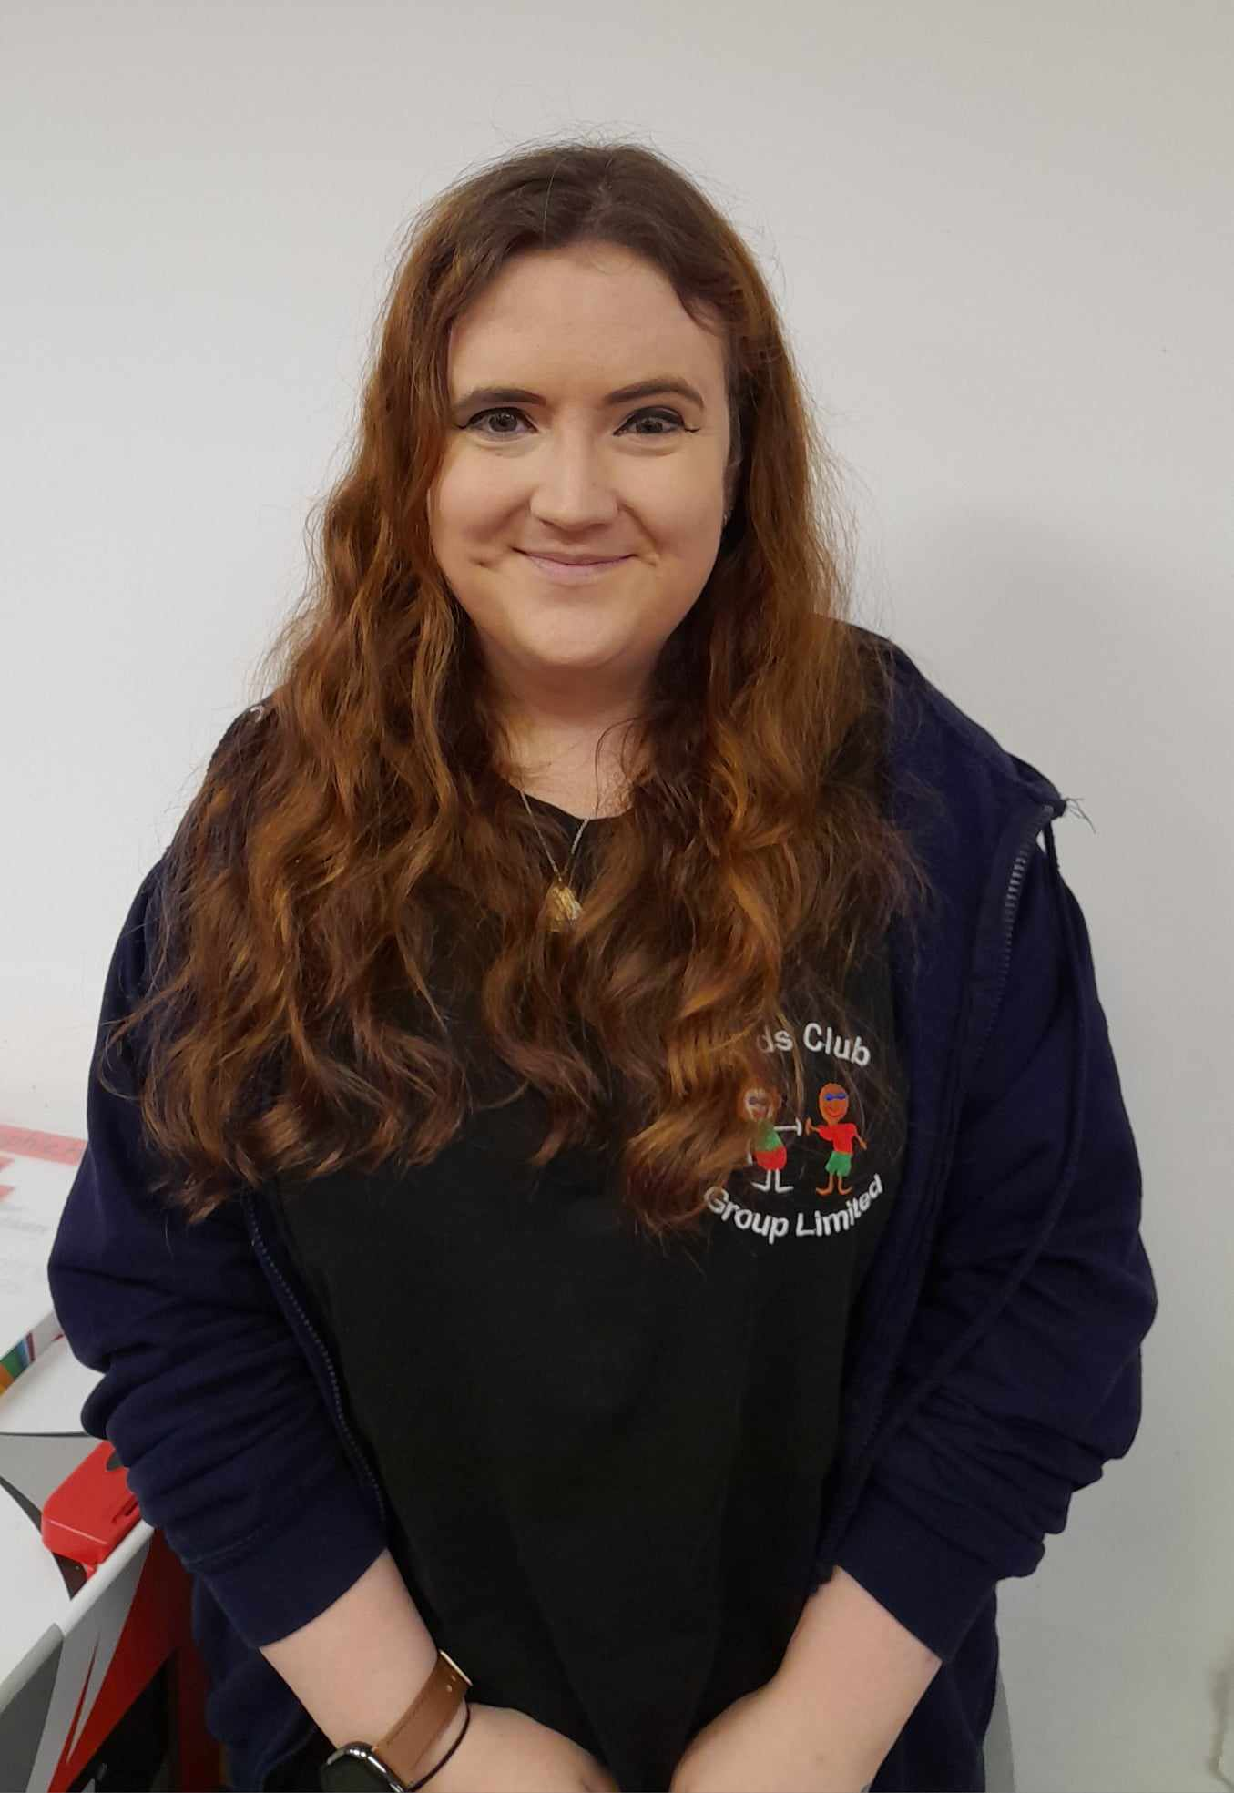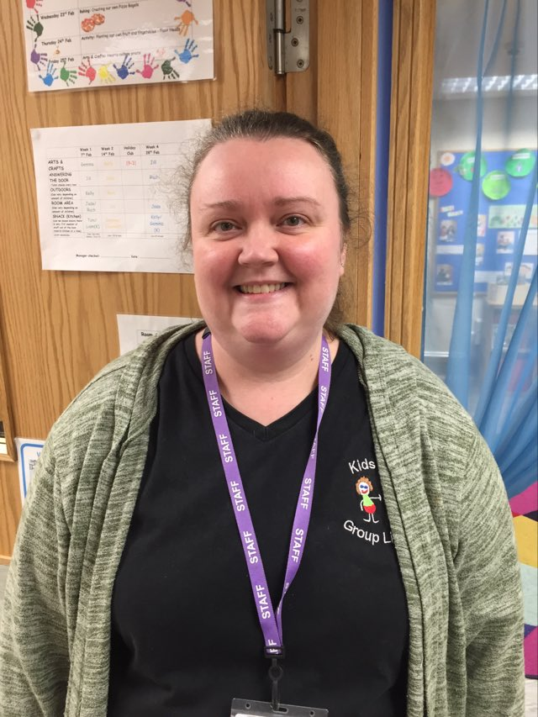
Our staff worked incredibly hard throughout the summer to create a safe, welcoming, and fun environment for all the children. Receiving your positive feedback and hearing about the difference we have made to your children's holiday experiences has been truly rewarding.
We are especially grateful for the many thoughtful emails, kind messages, cards, and words of appreciation received over the summer.
Thank you to everyone who took the time to send messages of thanks and recognition, it means alot to our staff and reminds us why we love what we do. xx

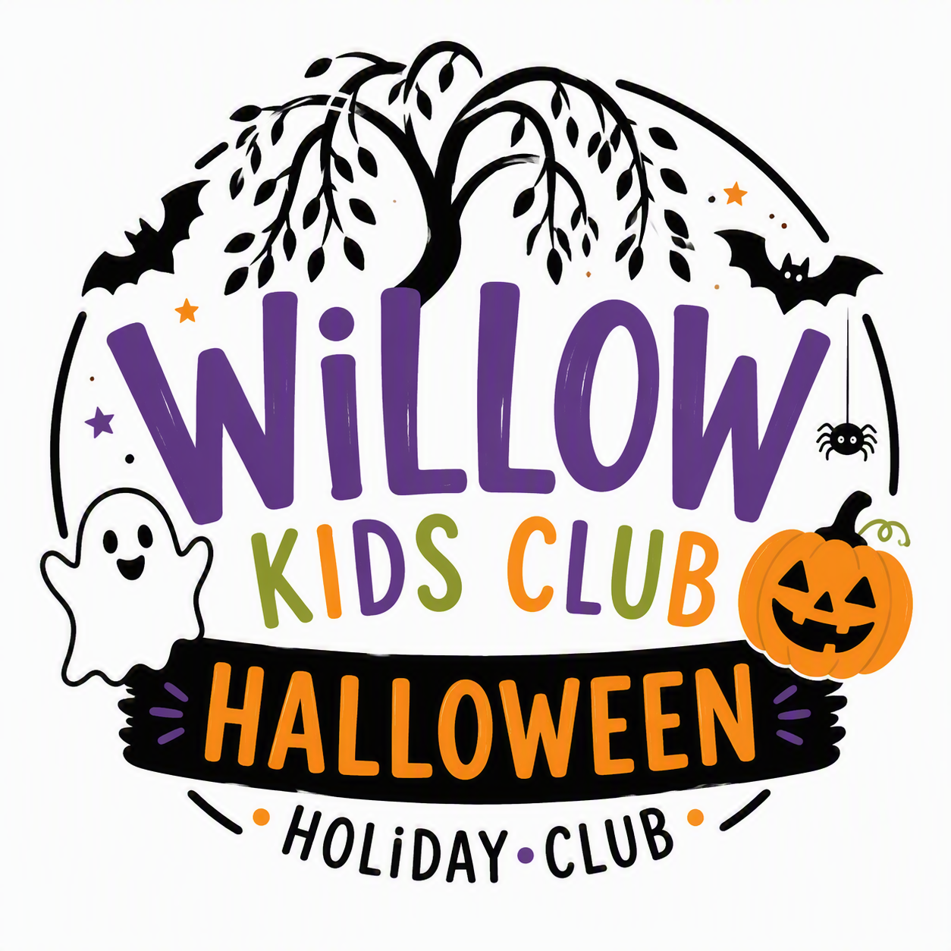


#

OCTOBER HOLIDAY CLUB!

Open From:
Friday 23rd October – Friday 30th October

Don’t forget to book your sessions to avoid disappointment

